**Walk 10 Wyevale Nursery**

Last walked in April 2017

**Description.** A 8 km (5 miles) easy walk along well defined tracks and roads.

**Start.** Explorer Map 202 Grid 490413

**Direction from Whitecross roundabout** (Turn milometer to zero). Take the A4110 Canon Pyon (Three Elms road). After ½ mile and just past the pedestrian lights TR to park in the RANGE store car park.

**1. Homebase.** Go back to the pedestrian lights and cross the main road. TL, 40m TR to go thru a kissing gate and onto a public footpath. ***In front of you and to the L is Whitecross Hereford High School. The form and design of the school is heavily determined by a strong sustainability agenda with natural lighting, green roofs, mechanical ventilation with heat recovery systems and the use of thermal mass to stabilize temperatures.*** After a short distance you go thru a small wooden gate into a field **F1**. You go very slightly L as you cross the field to pass a big lone stump of a tree, and then go thru a small metal gate and across a wooden footbridge into **F2**. Walk around the L hand edge of this field and go thru a metal gate onto a road, (Huntington Lane). TL, after a dozen paces you TR and cross the lane to go thru a small wooden gate into **F3**. Turn slightly R and head towards an electronic pylon. Half way across the field the track bears off slightly R and you go under more power lines to reach the edge of the field, where you go down five wooden steps and onto an enclosed track. TR and continue along the track to go thru a small wooden gate and onto the Roman Road.

**2. Roman Road.** Cross the Roman Road and go along Tow Tree Lane ahead. When the road bends R, you carry straight on along a gated road and bridleway, and after 100m you TL and go thru a small metal gate into a small field **F4**. Cross **F4** to cross over a wooden bridge into **F5**. Cross this field to go thru a small wooden gate and onto a main road (Roman Road). Go straight across the Roman Road to carry on up the road opposite, to go past the Livestock Market (L). At the end of the road, by tall metal gates and to the R of a ‘No Entry’ sign that’s painted on the road, you continue in the same direction along a tarmac path, and then along an enclosed grassy track. The enclosed track continues on, to go past Wyevale Nursery crops that are on your R, you then go thru a kissing gate/metal gate and continue on for a short distance to reach the main Hereford to Brecon road. Cross the road and TR, walk along the footpath, and not far past the entrance to Wyevale Nursery, and opposite a bus shelter on your R, you TL to go up an enclosed public Bridleway.

**3. Wyevale Nursery and Wyevale Wood.**Continue upto the T-junction at the top of the enclosed bridleway. ***On your L is Wyevale wood where you can sit down inside a bird watching wooden hut.*** TL and continue along a bridleway that initially runs just inside Wyevale wood, this bridleway was formerly called Green Lane. ***Wyevale Wood, formerly called Green Lane Wood, is secondary woodland on an ancient woodland site.*** ***Green Lane itself was originally part of a drover's road from the Welsh hills to Hereford and on to London. The 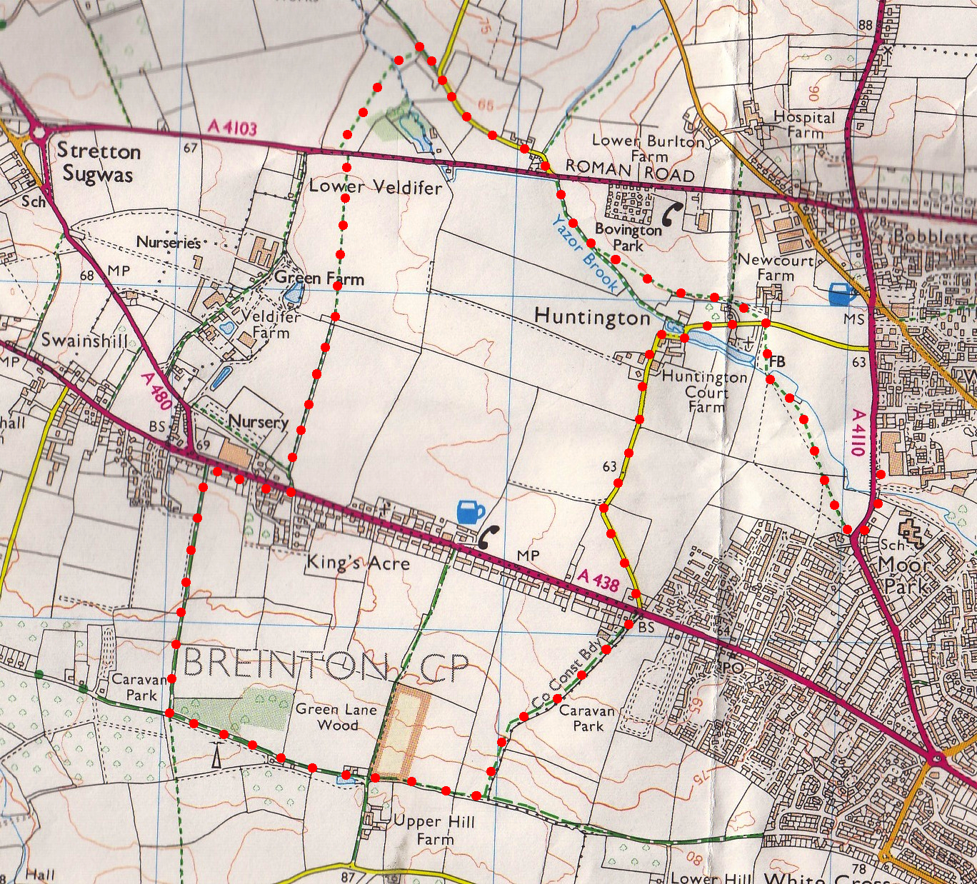drovers had an overnight stopping place at the "King's Acre", an area just east of the wood where there was a drinking pond for the animals.*** The bridleway widens out to become a stone track/road. Further on, just past a pond on your R, the road bends R, you go straight ahead and thru a hedge gap into **F6** and continue in the same direction, keeping to the hedge on your R, (ignore any way mark signs to your L, that go into ‘Drovers Wood). Continue on to the end of this field, thru a gap in the hedge and onto the end of the next field **F7** where you TL down a bridleway.

**2**

**4. Bridleway.** Proceed down hill, keeping to the hedge on your R. At the bottom you continue in the same direction along a tarmac drive to reach the main Brecon/Hereford road. Go straight across the road and along Huntington Lane. After a kilometre the road bends R, L and R again, and a little further on we get to the pathway to St Mary’s church on your R. ***The church isn't easy to see from the road, this is the very pleasant path leading down to it.*** Just passed the churchyard and opposite Newcourt Farm drive, you TR thru a metal gate and into **F2**. Follow the R hand field edge around to cross over a wooden footbridge, thru a small metal gate and into **F1**. Go straight across this field, and thru the kissing gate that’s near to Whitecross Hereford High School. Continue on thru another kissing gate and on to the road where you TL and then TR to cross over by the pedestrian lights. TL and carry on to the car park.

**4**

**3**

**1**